**PIZZA SALES SQL QUERIES**

* **KPI’S**

1. **TOTAL REVENUE :**

**SELECT SUM(total_price) AS Total_Revenue from pizza_sales;**

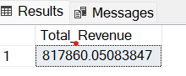

1. **AVERAGE ORDER VALUE :**

**SELECT SUM(total_price) / COUNT(DISTINCT order_id) As Average_Order_Value from pizza_sales;**

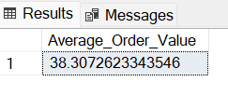

1. **TOTAL PIZZA SOLD :**

**SELECT SUM(quantity) As Total_Pizza_Sold from pizza_sales;**

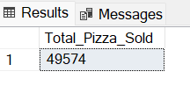

1. **TOTAL ORDERS :**

**SELECT COUNT(DISTINCT order_id) AS Total_Orders from pizza_sales;**

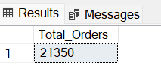

1. **AVERAGE PIZZAS PER ORDER :**

SELECT CAST(CAST(SUM(quantity) AS DECIMAL(10,2))/

CAST(COUNT(DISTINCT order_id) AS DECIMAL(10,2)) AS DECIMAL(10,2)) AS Avg_Pizzas_per_Order from pizza_sales;

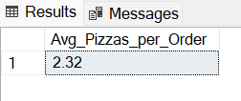

1. **PROBLEM STATEMENT**
2. **DAILY TREND FOR TOTAL ORDERS :**

SELECT DATENAME(DW, order_date) AS order_day, COUNT(DISTINCT order_id) AS Total_Orders

from pizza_sales

GROUP BY DATENAME(DW, order_date);

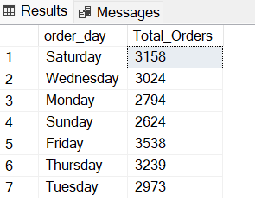

1. **MONTHLY TREND FOR TOTAL ORDERS :**

SELECT DATENAME(MONTH, order_date) AS Month_Name, COUNT(DISTINCT order_id) AS Total_Orders

from pizza_sales

GROUP BY DATENAME(MONTH, order_date)

ORDER BY Total_Orders DESC;

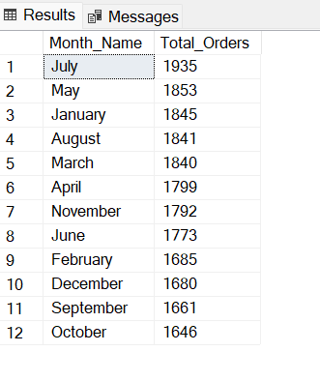

1. **PERCENTAGE OF SALES BY PIZZA CATEGORY :**

**SELECT pizza_category, SUM(total_price)* 100 / (SELECT SUM(total_price) from pizza_sales) As PCT --percentage of total sales(PCT)**

**from pizza_sales**

**GROUP BY pizza_category;**

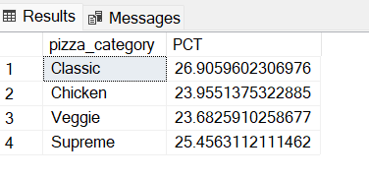

**NOTE :**

1. **Can also sort according to months (1-12) to get the PCT according to months :**

SELECT pizza_category, SUM(total_price)* 100 / (SELECT SUM(total_price) from pizza_sales WHERE MONTH(order_date) = 1 ) As PCT --percentage of total sales(PCT)

from pizza_sales

WHERE MONTH(order_date) = 1 --sorting according to month (1-12)

GROUP BY pizza_category;

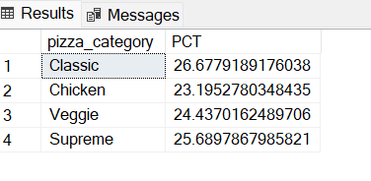

1. **Also can fetch the Total Sales(According to Month) :**

SELECT pizza_category, SUM(total_price) AS Total_Sales, SUM(total_price)* 100 / (SELECT SUM(total_price) from pizza_sales WHERE MONTH(order_date) = 1 ) As PCT --percentage of total sales(PCT)

from pizza_sales

WHERE MONTH(order_date) = 1 --sorting according to month (1-12)

GROUP BY pizza_category;

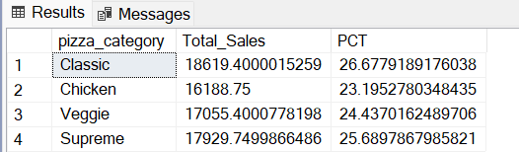

1. **PERCENTAGE OF SALES BY PIZZA SIZE:**

SELECT pizza_size, CAST(SUM(total_price) AS DECIMAL(10,2)) AS Total_Sales, CAST(SUM(total_price)* 100 /

(SELECT SUM(total_price) from pizza_sales

) AS DECIMAL(10,2)) As PCT --percentage of total sales(PCT)

from pizza_sales

GROUP BY pizza_size

ORDER BY PCT DESC;

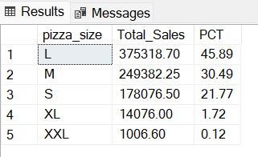

**NOTE :**

1. **Getting the output on QUARTER Basis(1-4) :**

**SELECT pizza_size, CAST(SUM(total_price) AS DECIMAL(10,2)) AS Total_Sales, CAST(SUM(total_price)* 100 /**

**(SELECT SUM(total_price) from pizza_sales WHERE DATEPART(QUARTER, order_date) = 1**

**) AS DECIMAL(10,2)) As PCT --percentage of total sales(PCT)**

**from pizza_sales**

**WHERE DATEPART(QUARTER, order_date) = 1**

**GROUP BY pizza_size**

**ORDER BY PCT DESC;**

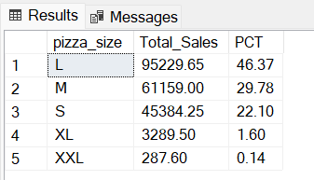

1. **TOP 5 BEST SELLERS BY REVENUE TOTAL QUANTITY AND TOTAL ORDERS:**

* **TOP 5 PIZZAS BY REVENUE:**

SELECT TOP 5 pizza_name, SUM(total_price) AS Total_Revenue FROM pizza_sales

GROUP BY pizza_name

ORDER BY Total_Revenue DESC;

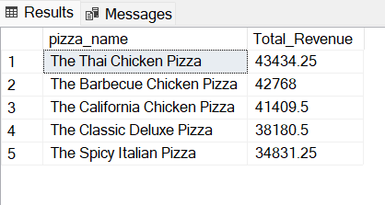

* **BOTTOM 5 PIZZAS BY REVENUE:**

SELECT TOP 5 pizza_name, SUM(total_price) AS Total_Revenue FROM pizza_sales

GROUP BY pizza_name

ORDER BY Total_Revenue ASC

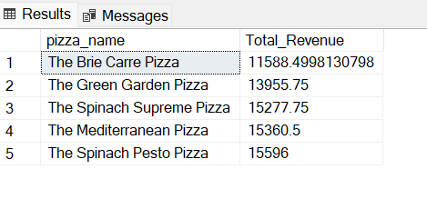

* **TOP 5 PIZZAS BY QUANTITY :**

**SELECT TOP 5 pizza_name, SUM(quantity) AS Total_Quantity FROM pizza_sales**

**GROUP BY pizza_name**

**ORDER BY Total_Quantity DESC;**

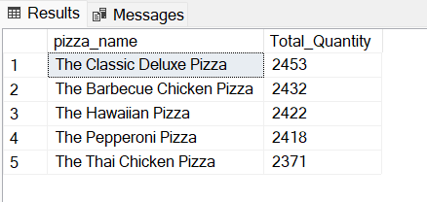

* **BOTTOM 5 PIZZAS BY QUANTITY :**

**SELECT TOP 5 pizza_name, SUM(quantity) AS Total_Quantity FROM pizza_sales**

**GROUP BY pizza_name**

**ORDER BY Total_Quantity ASC;**

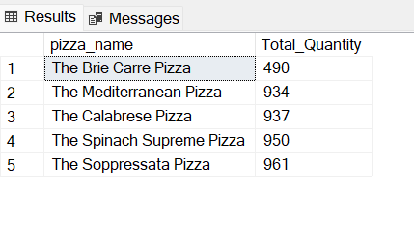

* **TOP 5 PIZZAS BY ORDERS :**

**SELECT TOP 5 pizza_name, COUNT(DISTINCT order_id) AS Total_Orders FROM pizza_sales**

**GROUP BY pizza_name**

**ORDER BY Total_Orders DESC;**

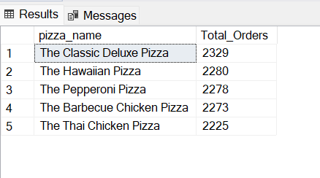

* **BOTTOM 5 PIZZAS BY ORDERS :**

**SELECT TOP 5 pizza_name, COUNT(DISTINCT order_id) AS Total_Orders FROM pizza_sales**

**GROUP BY pizza_name**

**ORDER BY Total_Orders ASC;**

